**Overview of School District Analysis**

The purpose of the analysis is to gain a high-level understanding of the school district’s performance metrics and present in a table format. The district wanted to identify the top 5 and bottom 5 performing schools based on overall passing rate.

The district wanted to analyze the average math and reading scores received by students in each grade level. They also wanted to identify any patterns in school performance based on budget per student, school size and types of school.

During the analysis the school board was notified about the 9th grade at Thomas High School showed evidence of academic dishonesty. I was tasked with replacing the math and reading scores for Thomas High School while keeping the balance of data intact. Once I replaced the scores, I was able to repeat the school district analysis.

This is was a fascinating exercise for me. I learned the following as part of completing the purpose.

* Opened Jupyter Notebook files from local directories using a development environment.
* Read external CSV files into DataFrames.
* Formatted DataFrame columns.
* Determined data types of row values in DataFrames.
* Retrieved data from specific columns of DataFrames.
* Merged, filtered, sliced, and sorted DataFrames.
* Applied the groupby functions to DataFrames
* Used multiple methods to perform functions on DataFrames.
* Performed mathematical calculations on columns of DataFrames and Series.

**Results**

The final analysis without the 9th grade scores the following was found:

* The entire district scores decreased to 64.86%
* Thomas High School scores decreased to 65% taking them out of the top 5 performing schools.



* The average performance scores improved by 6% for the 10th, 11th and 12th graders.
  + 93% of these students from Thomas High School passed math.
  + 97% of these students from Thomas High School passed reading.
  + The overall passing percentage was 90.6%
* Charter schools are the top 5 performing high schools.
* District schools are the bottom 5 performing high schools.
* Average scores and performance did not increase based on spending per student.

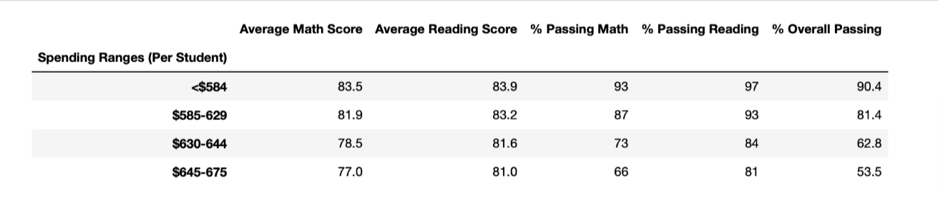

* Larger schools tended to have lower performing scores than smaller or medium schools.

